Mask-Afr-Guinée-Kissi-

Kissi soapstone fetish, ancestor statue 9.5in. high, base is 3.5 in x 2.5 in. 4 lbs. ca. 1100 CE-1850 CE.

Part of the left side of the base and leg is missing and there are small cracks on the left arm.

This statue is an example of the use of sympathetic magic and healing among the Kissi of French Guinée, which is known mainly from sculpted stones such as this, which are called Pomda or Pomtan (sing., Pomdo) "figures of the dead." As Denise Paulme noted in 1942 the Kissi would make offerings of food and blood sacrifice to these Pomda to propitiate spirits that could act on their behalf (Paulme 1942). While the practice appeared very ancient, the Kissi were limited in their knowledge of their past because they not only were they illiterate and could not keep any historical records but also they had been subject to dislocation and slavery under colonial governments and so had a collective memory that only extended some eight generations (Paulme 1946). This Pomdo statue can provide some clues as to the age of the practices associated with it. It has many pock marks on it which probably represent the pustules of a communicable disease like smallpox, and the statue's hands appear to be scratching these pustules. If this interpretation is correct then we have a fetish that was used to dispel disease by taking the disease from the afflicted one by sympathetic magic and embedding it in the statue if the correct propitiations were offered it. We have comparative data from the Yorubas of western Africa who also developed a similar reponse to smallpox. The Yoruba Orisha religion had a deity called Sopona, the god of smallpox, who, if displeased, could cause smallpox outbreaks. The name "Sapona" (also "Shapona," "Saponna") was like the tetrgrammon of Judaism, not to be spoken aloud for fear of incurring its wrath, so other epithets were used including "[Babalú-Ayé, the spirit of the Earth who was associated with both creating infectious disease and healing and so was both feared and loved.](http://en.wikipedia.org/wiki/Babalu_Aye) The age of the statue is uncertain but the tradition associated with it may be more than a thousand years old and so too might be the age of this statue: it may be connected witht the 6th century CE smallpox epidemic in west Africa. Smallpox was transmitted to western sub-Saharan Africa after the 568 CE "Elephant War," when Ethiopi­an troops, having been afflicted by the disease in their war with Mecca traveled along the caravan routes to west Africa. This transmission of smallpox in the 6th century CE was undoubtedly furthered in the 11th century CE by the advance of Islam, since smallpox was endemic in Saudi Arabia (Fenner et alii 1988). Indeed, Africa was one of the places in the world where smallpox remained the longest and was most highly endemic, and French Guinée was especially devastated by it. Even as late as 1962 the smallpox rate in French Guinée was 100/100,000 (Schneider 2009). The importance of this statue as a memorial to this most dreaded disease provides us with a chilling, potent, visual reminder of the early history of public health in western sub-Saharan Africa and the routes of transmission that could create such pandemics.

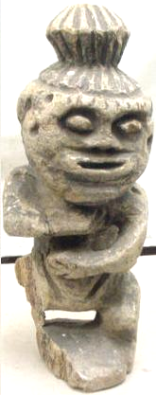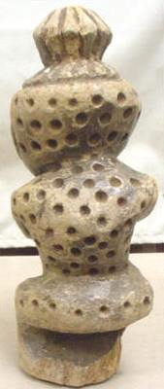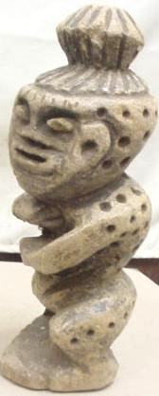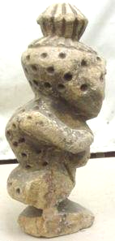

References:

Chevalier, Auguste. 1909. La Région des sources du Niger*. La* *Géographie.* 19(no 5): 337-352

Delafosse, M. 1914. Au sujet des sta­tuettes en pierre du Kissi*. Révue d'Ethnographie el de Sociologie,*pp.143-­144.

Fenner, D.A. Henderson, I. Arita, Z. Jezek, I.D. Ladnyi. 1988. Smallpox and its eradication: ch. 5, Smallpox in Africa between 1000 and 1900, pp. 233-234.

Idowu, E. Bolaji. [1962]. *Olodumare: God in Yoruba Belief*. London: Longmans, Green, and Co.

Laplagne, R. P. F. 1921. *Coutumes kissiennes au sujet des malades el des morts. Bul­letin du Comité d'Études Ilistoriques et Scientifiques de l'A. O. F.,* pp. 269-270.

Paulme, Denise. 1946. La notion de sacrifice chez un peuple « fétichiste » (les Kissi de la Guinée française), *Revue de l'histoire des réligions*, 132 (1-3): 48-66.

Paulme, Denise. 1942. Deux statuettes en pierre de Guinée française, *Bulletins et Mémoires de la Société d'anthropologie de Paris*, 3(3): 38-43.



Schneider W.H. 2009. Smallpox in Africa during Colonial Rule, *Medical History* 53(2): 193-227.

Tauxier, Louis. 1934. Sur les Kissi, Negres de La Guinée française et leurs sta‑

tuettes en pierre*, Anthropologie, 34:* 471-472.